Reading Lesson: Reread and Sketch

A quick introduction: https://youtu.be/Dnm8ErLsPBI

Rereading a text and sketching pictures can help us remember what we read!
Start with this video: https://youtu.be/B8u2GF5bmbs

Hedgehogs reading: https://kids.nationalgeographic.com/animals/mammals/hedgehog/

Example photo:
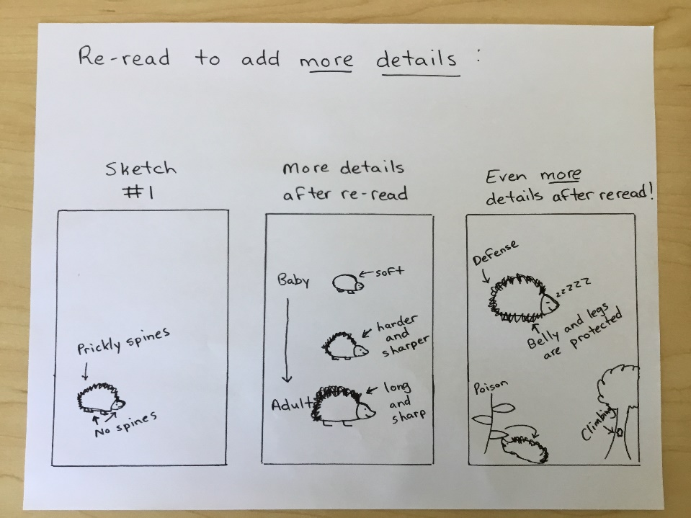

Wolverines reading: https://kids.nationalgeographic.com/animals/mammals/wolverine/

Find more animal texts at: https://kids.nationalgeographic.com/animals/

