Slap Jack

Number of Players: 2 or 3
Materials: Deck of Cards (remove the face cards)

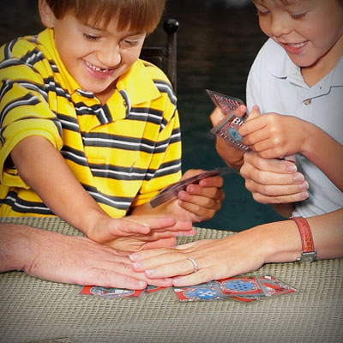
Instructions: Each player should get an equal number of cards to start the game. Each player will flip over a card from their pile and put it into the middle. The first player to add up all the numbers and slap the pile wins the round.
If you slap the pile and can’t say the answer within 5 seconds or you add the numbers together incorrectly, you are out for that round. Whoever wins collects the cards and puts them into their pile. The game is over when one player has got all the cards.
Variations: You can also play this game with more players or multiply/subtract instead of adding.

