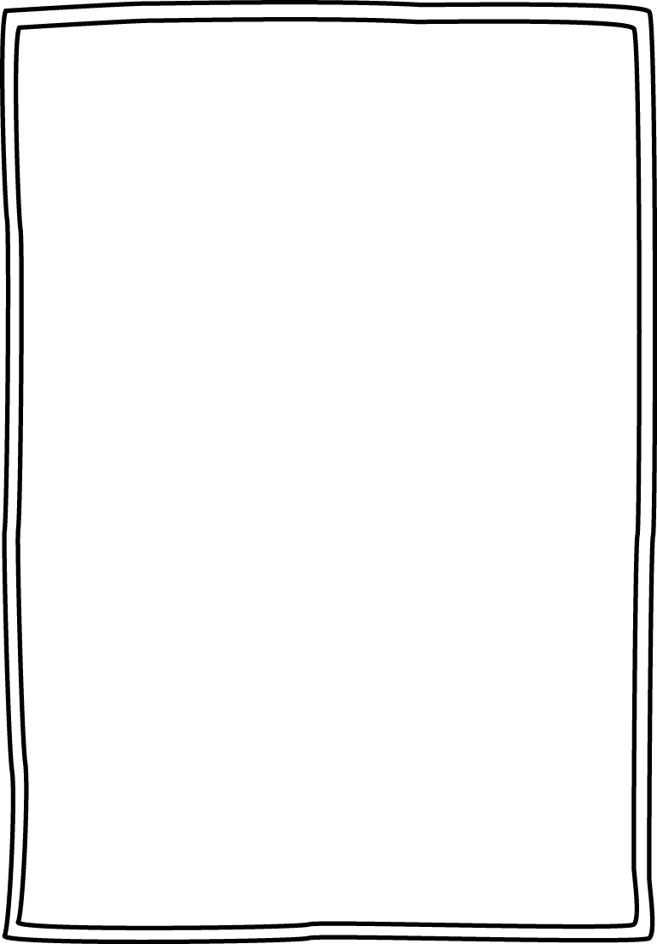

Buzz about BOOKS!

<https://www.youtube.com/watch?v=Xsu66BGiGAA>

Check out this lesson to learn more about making book recommendations!

You’ll get to create a super cool video and make your own book recommendation!

Everything you need to know is in the video below! Have fun!

