Multiplication Word Problems Practice
- The pictograph shows the number of bikes donated by 3 schools.
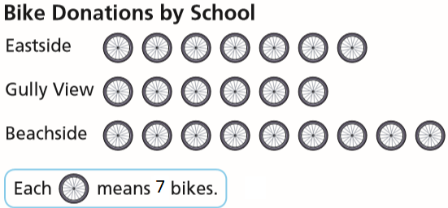
- Write an addition equation and a multiplication equation to show the number of bikes donated by each school.

- How many bikes were donated by each school?

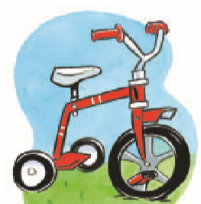
- How many wheels are on 6 tricycles? Show your work.

- How many legs are on 3 spiders? Each spider has 8 legs. Show your work.

- Mrs. Rogers needs to buy 30 bottles of water for the class fieldtrip. Mrs. Rogers bought 9 packages of water. Each package has 4 water bottles. Did she buy enough bottles for the trip?

