Reading Lesson: Ask Questions to Engage with Text

Asking questions while we are reading can help us read with a wide-awake brain and understand what we are reading!

Start with this video: https://youtu.be/9WQD_EcCN0s
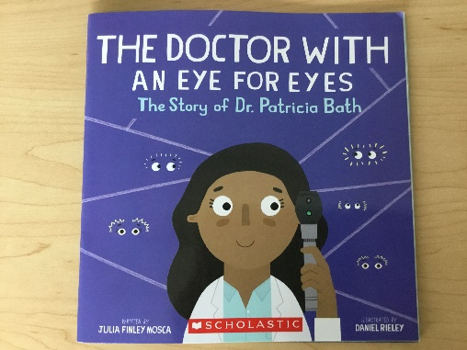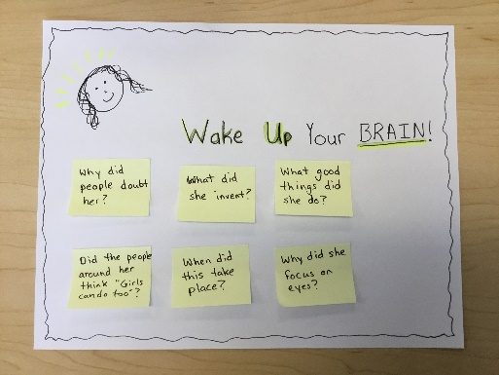

Your task today:
- Choose a book. It can be a picture book, chapter book, informational, or fiction.
- Read with a wide-awake mind. Write down at least 3 questions you have as you read.
- Review your questions. Were your questions answered by the rest of the book?
- Optional: Share your book and the questions you had with your teacher!

Feeling stuck? Try starting a question with who, what, where, when, why, or how. For example:
- What will come next?
- Why did the character do that?
- Why did the author include that information?
- Where is this taking place?

