Quebec Culture: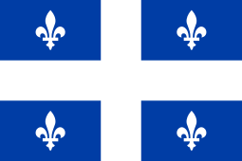
(Cirque du Soleil!)
Cirque du Soleil is a Montreal based Circus which began in 1984. “Cirque du Soleil” means “Circus of the Sun”! It is sometimes performed in a Grand Chapiteau – a big top circus tent!
Cirque du Soleil began with a group of street performers in Quebec. It now employs over 4000 people, and there are shows on every continent except Antarctica!
Cirque du Soleil’s talented artists are jugglers, acrobats, contortionists, dancers, singers, and actors. They are from all over the world!
Check out this cool video of a Cirque du Soleil juggler!
https://www.youtube.com/watch?v=ykQjrqEO_dU
Would YOU like to learn how to juggle? For some fun and exercise, check out these scarf juggling videos...

Here is a beginner video on scarf juggling...
https://www.youtube.com/watch?v=ve2FKNctOBg

Here is video on 3-Scarf juggling...
https://www.youtube.com/watch?v=uWiZ4fNqu5c
What if you don’t have scarves at home? Using plastic bags from the grocery store will work too!
Good luck and have fun!

