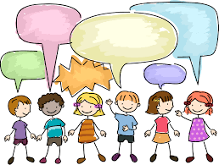
Who’s Speaking?

Have you ever had a moment while you are reading when you’ve paused and asked yourself, “Wait, who said that?”
In the books you’re reading now, you will probably come across conversations between characters. The author won’t always tell you who is talking. Watch the video below to learn more about figuring out who is talking.

Video Lesson: https://youtu.be/SJDYDEyiLq0

Your task today:
- Read the example below of a conversation between two characters.
- Use markers, pens, or a digital highlighter to identify each character’s words.
- Optional: Share a photo or screenshot of your finished work with your teacher.

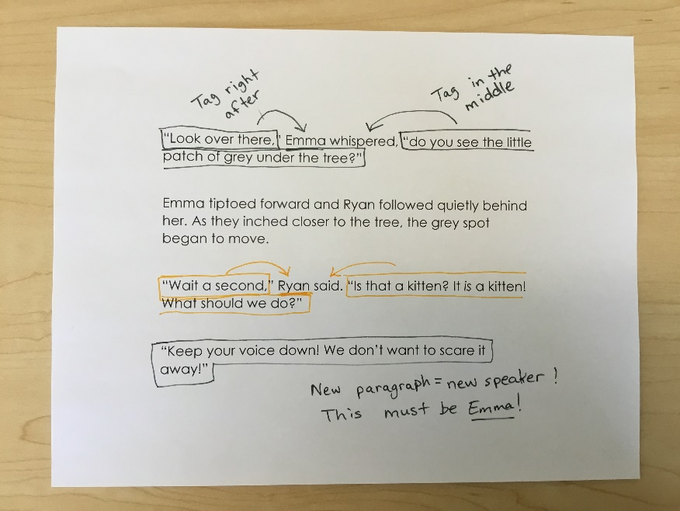

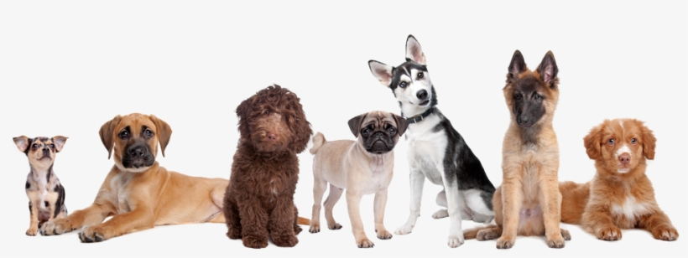
Example

Liz and Omar opened the Humane Society’s heavy door and their ears filled with the sharp sounds of dogs barking. They turned the corner and walked down the wide hallway, looking through each window as they passed. “I can’t believe all of these dogs need new homes!” said Omar.
As they walked, they saw lots of new dogs. “Hi little guy” said Liz to the small white dog with black spots.
“Whoa! You’re fast!” exclaimed Omar about a tan dog that was racing back and forth with the dog in the next kennel. They continued down the hall, looking through each window to find another dog staring back at them.
“This one is huge!”
“This one looks scared.”
“This one looks like my grandma’s dog.”
“Why are they all here?” Omar wondered.
“Look at this sign.” Liz pointed to a little white sign on a kennel door. “It says that this dog was found. I wonder where his owners are now. I wonder if someone is looking for him.”
Omar stepped across the hall and looked out the window at a large black dog with long hair. The dog tilted his head to the side and studied Omar. His wagging tail thumped against the fence. “Hey buddy! Look at you! Are you a good boy?” The dog jumped up onto the door, his front paws landing on the window with a soft thud, and stared directly into Omar’s eyes.
“I think he likes you.”

