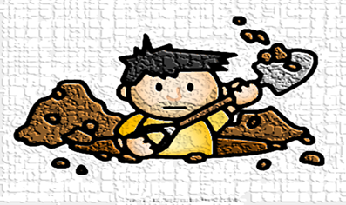
(PART TWO)
Last week, we learned that there are different layers of understanding when you read a story. I explained how you can dig deeper to develop a stronger understanding of stories through:
- Retelling
- Responding
- Reflecting
In Part One, you learned how to retell a story. You scratched the surface of the story. You restated the characters, setting and main problem that triggered a series of events. You told the important events in sequential order. You solved the problem by providing a solution to the initial problem.

Last week’s reading task focused on the first layer of comprehension, which is how to retell a story. We learned how to retell the story of Sam and Dave Dig a Hole by Mac Barnett and Jon Klassan using the Somebody Wanted….But…So…Then…strategy to summarize.

(Click on these video clips if you are unable to open the links above).
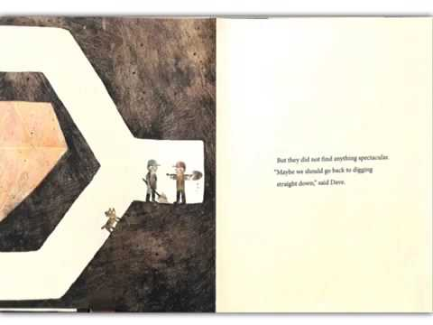

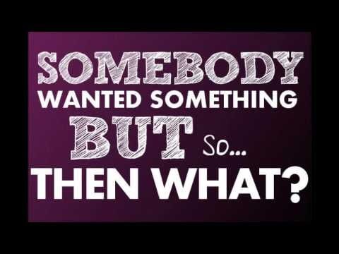

Now I am going to RESPOND to the story of Sam and Dave Dig a Hole.
This week, we are going to learn about how to dig deeper into stories by writing personal responses.
When you respond to a story, you use emotions or personal opinions to express how you feel about characters, events and outcomes. You justify your opinions or feelings using supporting details from the story. You rate the physical features (e.g. pictures, title page) of the book. You make connections between personal experiences and the text.

I thought the illustrator was so creative. He told his own story using pictures to show us what Sam and Dave missed during their digging adventure. The illustrations were simple but revealing! I loved the reactions of the dog because my dog always watches me. It makes me wonder what he is thinking. I think, maybe the dog was the smartest character of all. I feel so sorry for the two characters because they always just seemed to miss the secret treasures that were so close at hand. I just wanted to shout at them to dig a little more. It reminds me of how I am always the last one to find the Easter Eggs! I love happy endings so I enjoyed this book.
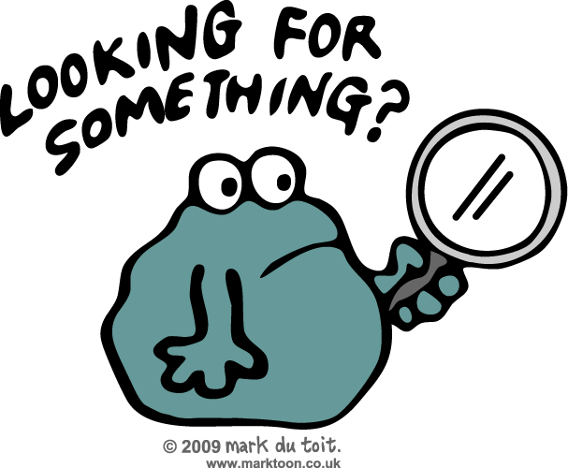
Now I will give you the opportunity to dig deeper into one of my favourite stories.
Please click on the link to read the delightful story entitled Three Cheers forTacky written by Helen Lester and illustrated by .
(Here is another video clip to view in case the link above does not work).
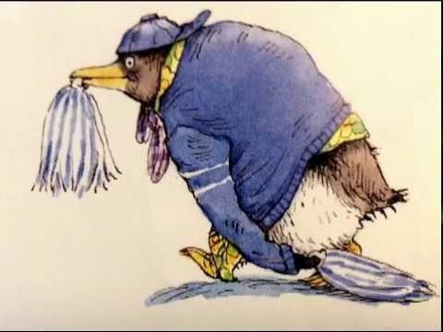

When you have finished viewing the book, I would like you to write a personal response about this story on a piece of lined paper. Remember, this is your reaction to the book based on your experiences, opinions or feelings. Feel free to generate questions or use several of the following sentences starters:
- My favorite part of the story was when…
- My least favorite character was…… because…
- I would/wouldn’t recommend this story because…
- This reminds me of the time I ……
- I really liked how the author……
- This book makes me feel ……because……
- One thing I would change in the book is……
- I am like the main character because…..

*Remember to be honest. Feel free to justify your feelings and opinions using your personal experiences or supporting details from the story!

Stay tuned next week, as we learn to reflect on stories to develop new perspectives, understand the author’s message, or learn life lessons!

