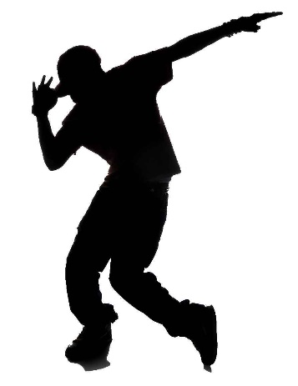
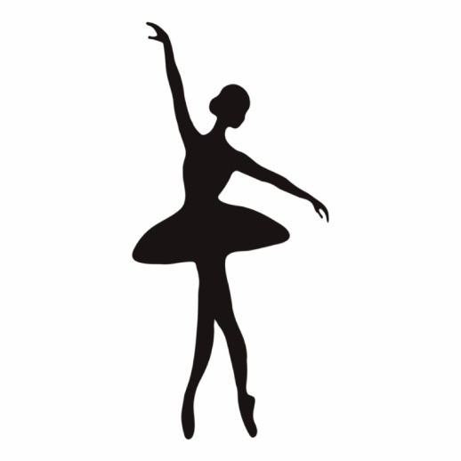
JUST DANCE!
DPA OPTION ACTIVITY

Hey kids!
Show off your dance moves!
Check out the links below for some fun dance-style workouts!
The first video introduces some basic dance moves, explained and taught by a real dance choreographer!

The second video is a fun, follow-along dance routine! Practice the basic moves and then give the routine a try! Have fun!!

Basic Dance moves
https://safeYouTube.net/w/c0tB

dance video
https://safeYouTube.net/w/ottB

