How do objects interact with light?

All objects can be identified as either opaque, transparent, or translucent depending on how much light they let through. Read below to find out more!

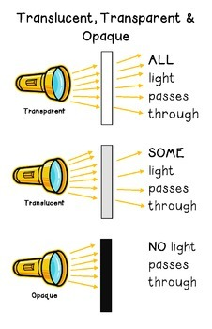

Science Lab Instructions

Find at least 10 objects that are around your house to use for this activity. Using a flashlight, determine whether the object is opaque, transparent, or translucent.

Household Object | Is the object Opaque, Translucent, and Transparent? How do you know?
Plastic Wrap | It is transparent because all the light was able to pass through the object. The plastic wrap was clear and see through.

