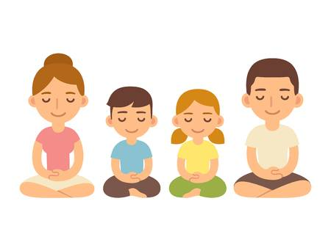
Guided Meditation
Health Activity

Hey kids!

Today we are going to practice some mindfulness. Mindfulness means paying full attention to something. It means slowing down to really notice what you’re doing right now in the moment. Being mindful is the opposite of rushing or multitasking.

We are going to listen to some guided meditation to practice being still and focusing on the feelings in our bodies and our minds. Meditation is helpful for lowering stress & anxiety, and improving self-awareness and confidence!

Find a comfortable, quiet space to complete this activity. Take a few deep breaths to get settled. When you’re ready, follow the link below for the meditation activity.

Guided Meditation

https://safeYouTube.net/w/NquB

