Hey Kids!
Read the message below to partake in the Virtual Jump Rope for Heart, as well as some fun activities each week for the next month!
Join us for #VirtualJump!
Starting Monday, May 25, Heart & Stroke is sharing free, downloadable activities for families to do at home together. Each week will focus on a different EASY healthy habit
The goal is 100,000 kids helping kids and learning healthy habits at home.
To begin receiving weekly activities throughout the month of June, join us!
Join Us

If you sign up for #VirtualJump, you will get some free activities from Heart & Stroke sent to you at home! Each week will focus on a different EASY healthy habit. We will also give you some activity ideas here, too!
For this first week, E is for Eat fruits & vegetables!
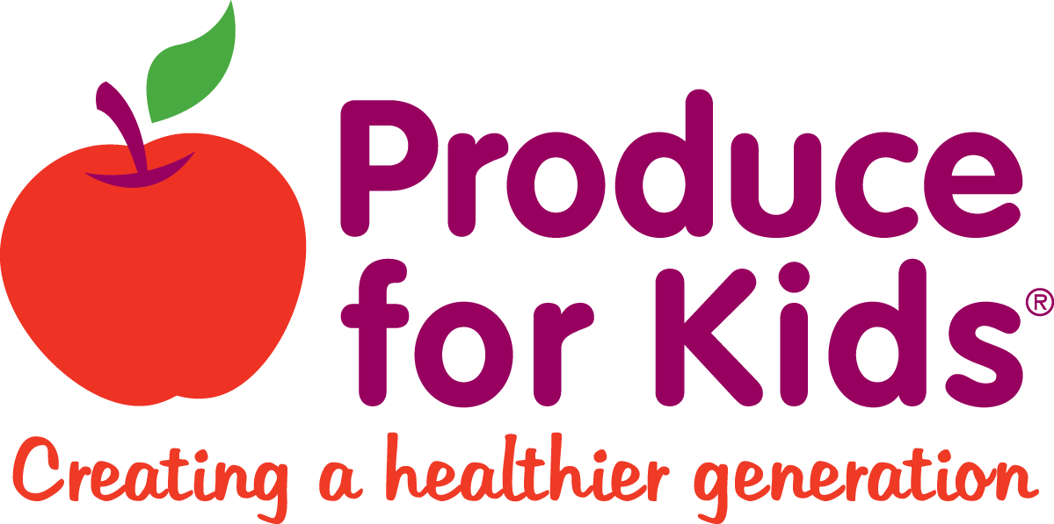
To help you eat more fruits & veggies, check out this website for some healthy recipes!

https://produceforkids.com/

You can use the Fruit & Veggie Tracker document on the Grade Four website to track your healthy eating this week! Happy healthy eating!

