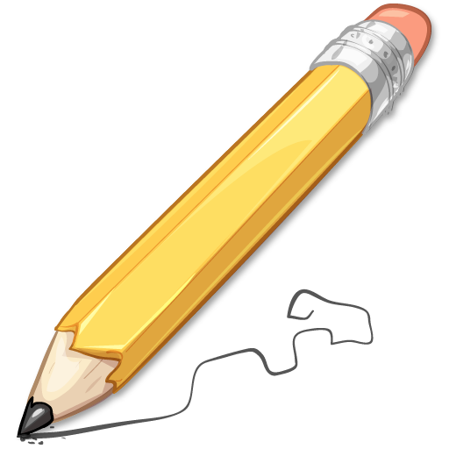
Nonfiction Article: Text Mapping and Comprehension

Hey kids!

Today we are going to be exploring some nonfiction! Nonfiction is writing that is based on true information and facts! For today’s lesson, you are going to get to explore magazine articles using the Scholastic website. You will get to check out the website and click around to choose a magazine article that you find interesting! Once you’ve chosen an article you will read it once through first to find out what it is about. Then, we will go back and do some text mapping (which is a close re-reading of the text) to find specific details and practice some reading strategies like inferring, summarizing, connecting and evaluating!

Let’s get started!

Step 1: Follow this link to watch a video showing how to get to the website and the articles:

https://share.vidyard.com/watch/aQD31DuLN4eQrzYJ2M7TJx?

Step 2: Pick an article you’d like to read! I chose the article on Zebras, but you can see there are many others to choose from too!

Step 3: Give your article a First Reading. Get the main idea of what it is talking about and see what you can learn! Make sure you read the pictures, too! They are important parts of the text.

Step 4: Re-read and complete the Text Mapping & Comprehension Activity below! There are three tasks for you to do!

*If you can print out your article at home, you can do the Text Mapping (Task 2 below) activity by writing right on your copy of the text.
If you don’t have a printer, you will still complete Task 2 (by doing a close reading and locating) but you won’t write on the article. Complete Tasks 1 & 3 also!

Before you complete Step 4, look below for some extra reminders for you!

**Remember:

- “Graphics/Illustrations” also mean “pictures.”
- “Topic” means: What is the article about?
- “Infer” means to make a prediction based on evidence/knowledge – it’s a smart guess!
- “Summarize” means to tell the most important details, like you were explaining the article to someone who asked you, “What was the article about?”

Nonfiction Article: Text Mapping and Comprehension

Name ____________________________________________________
Task 1: Sourcing

Title of Article:
Author (if one is included):
Source (Magazine, Newspaper, Website - if it is included)

Task 2: Annotation
Complete the following text mapping activity.
Important information | Put a star next to it | Names of People (including groups such as First Nations or World Wildlife Fund) | Blue Box
Keyword or detail | Underline | Places (i.e. cities, forts, countries, etc.) | Red Box
Things you understand | Put a check next to it | Dates | Green Box
Words you don’t know | Circle them | Events (like battles or rebellions) | Highlight
Things you don’t understand | Put a question mark next to it

Task 3: Understanding the Article
1. What is the topic? The topic is not the title. What is the topic that the passage explains?

2. Nonfiction Elements: How do the graphics and illustrations help you better understand the article?

3. Infer the main idea of a paragraph: What is the main idea of the first paragraph?

4. Infer the main idea of a paragraph: What is the main idea of the last paragraph?

4. Write a sentence that summarizes the beginning, the middle and the end of the article.

Beginning
End
Middle

5. Infer the main idea of a passage. What is the main idea of the whole passage?

6. Non Negotiables
Imagine that you had to explain this article in front of an entire class. What 10 words should be included in your summary? Remember: Non Negotiables mean these words are a MUST if you are summarizing correctly.

