Minor Remainders

Skills: Division of a Two-Digit number by a one-digit number.
Equipment: Cards (Ace=1) – 9, paper, pencil
Getting Started: Each Player selects three cards from the top of the deck and arranges these to create a division sentence resulting in the smallest possible remainder.
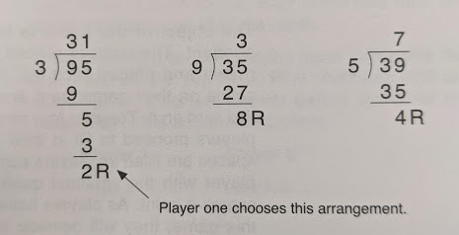
Example: Player 1 -> 3 9 5

The player with the smallest remainder receives one point. In the event of a tie (both players have equal remainders, then both players earn a point). The winner is the player with the most points after 10 rounds.

Variation: Vary the number of cards to modify the level of difficulty.

