Hey Kids!
Read the message below to partake in the Virtual Jump Rope for Heart, as well as some fun activities each week for the next month! We are on week four now! Remember: Virtual Jump is on June 19th!

Join us for #VirtualJump!
Starting Monday, May 25, Heart & Stroke is sharing free, downloadable activities for families to do at home together. Each week will focus on a different EASY healthy habit
The goal is 100,000 kids helping kids and learning healthy habits at home.
To begin receiving weekly activities throughout the month of June, join us!
Join Us

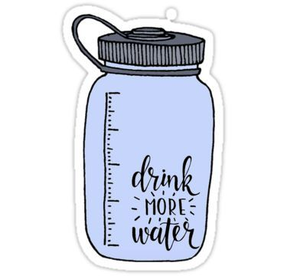
If you sign up for #VirtualJump, you will get some free activities from Heart & Stroke sent to you at home! Each week will focus on a different EASY healthy habit. We will also give you some activity ideas here, too!

For this final week, Y is for Yes to water: No sugary drinks!

You can use the Water Tracker (on the Grade Four website) to help you stay hydrated!

